EDGEFIELD
METHODIST CHURCH

Morning Worship 8:30 A.M. & 10:30 A.M. Sunday School 9:30 A.M.

Order of Worship for October 25, 2026

Prelude Welcome & Prayer Pastor

*Call to Worship “Sanctuary” Screen

*Apostle’s Creed No. 881

*Hymn “I Am Thine, O Lord” No. 419; vv. 1, 2, 4

Announcements/Reminders

The Worship of God with Tithes and Offerings

Children’s Sermon Celebration of Birthdays and Anniversaries

Prayer Requests, Pastoral Prayer and Lord’s Prayer

Scripture Amos 8:1-12

Anthem James Cox

Sermon “Bad Moon A Rising” Pastor Estel

*Hymn “Freely, Freely” No. 389:vv. 1-2
*Benediction
Pastor: The Lord Bless You and Keep You;
People: The Lord make his face to shine upon you, and be gracious unto you;
The Lord lift up his countenance upon you, and give you peace.



OPPORTUNITIES FOR THE WEEK
Sunday:
8:30 am – Early Worship
9:30 am – Sunday School
10:30 am – Worship
After Worship - “Table for One?” at Chef Alfredo’s in Piney Flats
6:00 pm – Youth
Monday, Tuesday, and Saturday: Quilters for the Homeless
Tuesday:
4:00 to 6:00 pm - Hymnal Craft class in CLC. Supplies will be available if you have scissors and glue gun, please bring, all other supplies will be on hand. These will be used as table decorations and for shut-ins. Contact Teresa Oler with questions.
Wednesday:
9:00 am – Mayberry Bible Study
10:30 am – Dulcimer Session this week
6:00-7:00 pm – Trunk or Treat at CLC
7:00 pm – Choir Practice
Saturday:
8:00 am – Prayer Time in Sanctuary
Next Sunday:
7:30 am – Methodist Men’s Breakfast in CLC
All Saints Sunday

A Big Thank You to Janet, the committee and all who helped to make Homecoming a rousing success. Pastor Estel

Congratulations to Gracyn Fox on passing the Bar Exam.

Congratulations to Jim & Verlyn Hearn on their new great granddaughter, Reese Renee Hearn was born on Oct. 14. She weighed 8lbs 3oz. The proud parents are Davis and Sarah Hearn who live in Dallas, TX.

The Piney Flats Ruritan will be hosting the 25th Annual Veterans Luncheon on Saturday, November 7 at the Edgefield Church Christian Life Center. This event is to recognize and honor our veterans. All veterans and their spouse or guest is invited. Please RSVP by Friday, Oct. 30. Send email to pineyflatsruritan@yahoo.com or call or text 423-737-1254.

Morning Worship – 153 Operating Funds………….…....$ 7,438.00
Sunday School – NA Budget Goal per week….......$ 5,518.00
Other Gifts:
Opportunity Fund……….......$ 100.00
Pastor Estel’s cell: 423-963-9071 Food Pantry……………….…$ 3,200.00
Pastor Estel’s email: pastorestelccp@yahoo.com Youth Fund……………….....$ 150.00
Holston Home………………$
Quilters……..……….………$

Announcements and Schedules:
Nov. 4 – 7:00 am – Men’s Prayer Breakfast at Bojangles
Nov. 7 – Noon – Veterans Luncheon in CLC
Nov. 14 – 10:00 am – Women’s Meeting in CLC
Nov. 14 – 3:00 pm – Wedding of Tori Thrash and Steve Bradford in Loe Wolf, Oklahoma
Nov. 15 - 2:00 pm – Paper Angels @ Dawn Tuck’s Home
Nov. 20 – 10:15 am – Food Pantry Run & Unload
Nov. 21 – Thanksgiving Meal
Nov. 21 – 8:30 am – Food Pantry Distribution
Nov. 22 – 4:00 pm – Charge Conference at Edgefield
Nov. 22 – 6:00 pm – Thanksgiving Service @ St. Paul Church

Assignments:

Acolytes:
……………….…………… Oct. 25 – Michael Davis
………………………….... Nov. 1 – Sha Kendrick, Kelley Whitehead
…………………………… Nov. 8 – Rowan Chapman
Ushers:
…………………………… Oct. 25 – Mike Chapman, James & Trayé Collett, Seth Copeland
……………....................... Nov. 1 – John Fandl, Bodey Fox, Noah Glover, Chris Hodge
………………………......... Nov. 8 – Bob Hudson, Jeff Hyder, Eli Johnson, George Kendrick
Greeters:
…………………………..... Oct. 25 – Morgan & Lily Parker (Evelyn Hunt)
…………………………….. Nov. 1 – Tammie Casasola, Mary Beth Sidebottom (Jim Hope)
…………………………...... Nov. 8 – Helen & Sha Kendrick (Linda Hodge)

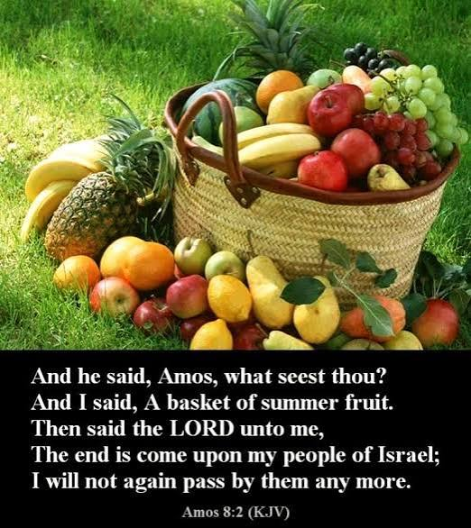

October 25, 2026

Edgefield Methodist Church
and St. Paul Campus
745 N. Pickens Bridge Road, Piney Flats, Tennessee 37686
(423) 538-5940 email:edgefieldgmc@gmail.com
Church Website: espgmc.org

Estel Williams, Pastor
Tim Knisley, Associate Pastor

“Edgefield Methodist Church is a supportive fellowship
where anyone can become a disciple of Jesus Christ”

