EDGEFIELD
METHODIST CHURCH

Morning Worship 8:30 A.M. & 10:30 A.M. Sunday School 9:30 A.M.

Order of Worship for March 15, 2026 Prelude DULCIMERS First Service

Welcome & Prayer Pastor
*Call to Worship “His Name Is Wonderful” No. 174

*Apostle’s Creed No. 881

*Hymn “There’s Within My Heart a Melody” No. 380; vv. 1, 2, 5

Announcements/Reminders

The Worship of God with Tithes and Offerings

Children’s Sermon Celebration of Birthdays and Anniversaries

Prayer Requests, Pastoral Prayer and Lord’s Prayer

Scripture Genesis 16:13

Anthem

Sermon “The God Who Sees” Pastor Suzanne

*Hymn “Tis So Sweet to Trust in Jesus” No. 462 vv. 1 & 4

*Benediction
Pastor: The Lord Bless You and Keep You;
People: The Lord make his face to shine upon you, and be gracious unto you;
The Lord lift up his countenance upon you, and give you peace.

OPPORTUNITIES FOR THE WEEK

Sunday: Fourth Sunday of Lent
8:30 am – Early Worship
9:30 am – Sunday School
10:30 am – Worship
12:15 pm - The Chosen Series 5: We will show Episode 1@12:15 today. This will give us time to watch the show, discuss, and then go to the games activity at 2. The following dates will be reserved for The Chosen. Study guides will be provided for those who would like them. March 29 (E2): 2-3 pm, April 19 (E3): 2-3 pm, May 3 (E4): 2-3 pm, May 17 (E5): 2-3 pm, May 31 (E6): 2-3 pm. There are 8 episodes in this season, the remaining two have not been scheduled.
2:00-4:00 pm – Game Afternoon for Older Adults in CLC (Rook, Checkers, Uno, Dominoes,
Board Games/bring your own also) popcorn and drinks provided
6:00 pm – Youth Monday, Tuesday, and Saturday- Quilters for the Homeless Wednesday:
9:00 am – Mayberry Bible Study
10:30 am – Dulcimer Session
6:00 pm – Bible Study: I- III John (Zoom & CLC)
7:00 pm – Choir Practice
Friday:
10:15– Food Pantry Unload
Saturday:
8:00 am – Prayer Time in Sanctuary
8:30 am – Food Pantry Distribution
Next Sunday:
After Worship - “Table for One?” at Chef Alfredo’s in Piney Flats
Diva and Dude Diamond Dotz Arts and Crafts. Starting on March 22 at the CLC, 2:00 pm. Come and meditate, fellowship and create a beautiful Diamond Dotz project. Keep it, donate it, save it for a present. It's yours to keep and decide what to do with it. Diamond Dotz is a fun, relaxing way to create something beautiful. Evelyn Hunt and Sherry Blizzard will be there to introduce you to this fun and easy craft. It's free and fun...come out and join us.

April 4- 2:00 pm – Children’s Easter Egg Hunt. We need candy for treat bags for the kids! Please bring individually wrapped bags of candy. Do not bring opened bags of jelly beans! There will be a basket in the front of the church to put your candy! Invite friends and family to the Easter Egg Hunt.

Morning Worship – 92 Operating Funds………….…....$ 28,299.00
Sunday School – 31 Budget Goal per week….......$ 5,518.00
Other Gifts:
Opportunity Fund $ 220.00
Pastor Estel’s cell: 423-963-9071 Food Pantry $
Pastor Estel’s email: pastorestelccp@yahoo.com Youth Fund $ 140.00
Suzanne Whittaker: 540-599-5301 Holston Home………………$
Suzanne: swhittaker@midsouthgmc.org Quilters……..…………….…$
Missions……..……………...$

Announcements and Schedules:
Mar. 27 - 10:15– Food Pantry Unload
Mar. 29 – 6:00 pm - Palm Sunday Service at St. Paul Church
Apr. 1 - 7:00 am – Men’s Prayer Breakfast at Bojangles
Apr. 2 – 7:30 pm – Maundy Thursday Service
Apr. 4 – 10:00 am-1:00 pm - The Edgefield Ladies Group will be having their "Easter Bake Sale" at JD Metals (beside Bojangles). We would greatly appreciate any and all baked items from members of the church. Cakes, pies, cookies, brownies, bread, etc would be appreciated. You can drop your items off at the church on Friday, April 3 from 6-7 or drop off at the bake sale by 9:30 on April 4. Come and get your "goodies" for Easter Sunday! Please make sure all items are in containers that close and label your items. Please make note if peanuts are used for those with peanut allergies.
Apr. 5 – 7:00 am - Sunrise Service at CLC
Apr. 5 – 8:30 & 10:30 am – Easter Services
Apr. 11 – 10:00 am – Women’s Meeting in CLC
Apr. 12 - 2:00-4:00 pm – Card Ministry @ Dawn Tuck’s Home (906 Denvers Lane)
Apr. 17 – 10:15– Food Pantry Unload
Apr. 18 – 8:30 am – Food Pantry Distribution
Apr. 18 – 5:30-7:00 pm - Bingo Night! One card for $5.00
or 3 for $10. Cookies and drinks provided. Lots of great prizes, including two –black-out $50 gift cards or one $100 black out gift card. Proceeds from this event will assist Aly Whittaker’s journey to Africa and any expenses not covered by the Mid-South Global Methodist Church. Children 12 and under will be able to play three games with one free card.
Assignments:

Acolytes:
……………….…………… Mar. 15 – Thomas & Lucas Hodge
………………………….... Mar. 22 – Logan & Haylie Minton
…………………………… Mar. 29 – Savanna Whitehead
Ushers:
……………………………. Mar. 15 – Ken Arnold, Mike Chapman, James & Trayé Collett
……………......................... Mar. 22 – Seth Copeland, John Fandl, Bodey Fox, Chris Hodge
………………………......... Mar. 29 – Bob Hudson, Eli Johnson, Jeff Hyder, George Kendrick
Greeters:
…………………………..… Mar. 15 – Shirley Smith, Ellen Torbett (Teresa Oler)
…………………………...... Mar. 22 – Barb Jara, Janet Elliott (Trish Shipley)
…………………………….. Mar. 29 – Cathy Lewis, Vickie Torbett (Peggy Grubb)

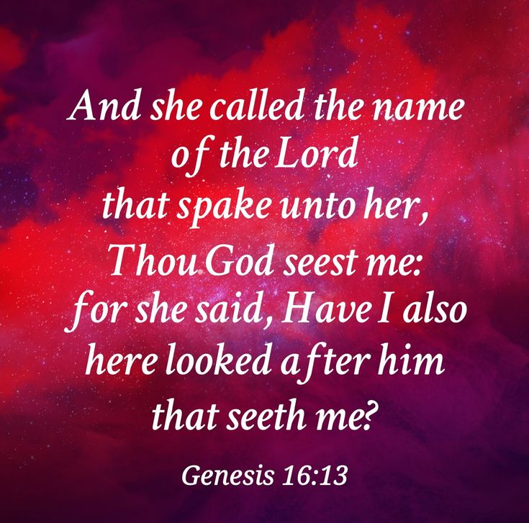

March 15, 2026

Edgefield Methodist Church
and St. Paul Campus
745 N. Pickens Bridge Road, Piney Flats, Tennessee 37686
(423) 538-5940 email:edgefieldgmc@gmail.com
Church Website: espgmc.org

Estel Williams, Pastor
Suzanne Whittaker, Associate Pastor

“Edgefield Methodist Church is a supportive fellowship
where anyone can become a disciple of Jesus Christ”

