EDGEFIELD
METHODIST CHURCH

Morning Worship 8:30 A.M. & 10:30 A.M. Sunday School 9:30 A.M.

Order of Worship for September 6, 2026

Prelude Welcome & Prayer Pastor

*Call to Worship “I Will Serve Thee” screen

*Apostle’s Creed No. 881

*Hymn “Open My Eyes, That I May See” No. 454; vv. 1-3

Announcements/Reminders

The Worship of God with Tithes and Offerings

Children’s Sermon Celebration of Birthdays and Anniversaries

Prayer Requests, Pastoral Prayer and Lord’s Prayer
Scripture Mark 2:1-12

Anthem “Come and Dine” Choir

Sermon “They Tore the Roof Off the Place” Pastor Estel

HOLY COMMUNION

*Hymn “’Tis So Sweet to Trust in Jesus” No. 462; vs. 1

*Benediction

Pastor: The Lord Bless You and Keep You;
People: The Lord make his face to shine upon you, and be gracious unto you;
The Lord lift up his countenance upon you, and give you peace.



OPPORTUNITIES FOR THE WEEK
Sunday:
8:30 am – Early Worship
9:30 am – Sunday School
10:30 am – Worship
6:00 pm – Youth
Monday, Tuesday, and Saturday: Quilters for the Homeless
Wednesday:
7:00 am – Men’s Prayer Breakfast at Bojangles
9:00 am – Mayberry Bible Study
10:30 am – Dulcimer Session this week
6:00 pm – Bible Study: Revelation (Zoom & CLC)
7:00 pm – NO Choir Practice
Saturday:
8:00 am – Prayer Time in Sanctuary
10:00 am – Women’s Meeting in CLC
Next Sunday:
2:00 pm – Paper Angels @ Dawn Tuck’s Home
5:00 pm – Church Picnic at Tim and Camille O’Neill’s, 287 Riverview Drive, Johnson City. Bring a chair and a side dish. Hamburgers and hot dogs will be provided.

Sympathy is extended to Pat, Travis and LeAnn and Family in the death of Bill Powell.

A Special welcome to our new Associate Pastor, Tim Knisley, his wife, Jesse and their son, Peter.

The Ladies Group will be collecting men’s white tube socks and men’s large underwear for Shades of Grace. There will be a tote in the vestibule to collect these items. Anyone that would like to help us in collecting these items will be greatly appreciated.

The Ladies’ Retreat will be held Oct. 21-25, 2026 in Myrtle Beach. All ladies of the church are invited. This is a weekend of fun, fellowship, devotions, and good food. If you would like to go on this retreat please let Patty Williams or Etta Hyder know by September 6.

Morning Worship – 90 Operating Funds………….…....$ 6,001.00
Sunday School – NA Budget Goal per week….......$ 5,518.00
Other Gifts:
Opportunity Fund……….......$ 100.00
Pastor Estel’s cell: 423-963-9071 Food Pantry……………….…$ 40.00
Pastor Estel’s email: pastorestelccp@yahoo.com Youth Fund……………….....$ 100.00
Holston Home………………$ 876.00
Quilters……..……….………$

Announcements and Schedules:
Sept. 16 – 6:30 pm – Young Adult Ministry
Sept. 17 – 6:30 pm – Homecoming Meeting in CLC
Sept. 18 – 10:15 am – Food Pantry Run
Sept. 19 – 8:30 am – Food Pantry Distribution
Sept, 25 – 10:15 am – Food Pantry Run
Sept. 26 – Lord’s Acre Sale (Breakfast will start at 8 am and end at 10:00 am.) The auction will start at 9:30 am. All other areas will be selling items until 12:00 pm.
Sept. 27 – After Worship - “Table for One?” at Chef Alfredo’s in Piney Flats
Oct. 4 - 7:30 am – Methodist Men’s Breakfast in CLC

Assignments:

Acolytes:
……………….…………… Sept. 6 – Michael Davis
………………………….... Sept. 13 – Hayley & Logan Minton
…………………………… Sept. 20 – Lily Parker
Ushers:
…………………………… Sept. 6 – Aaron Tuck, John Weaver, Adam & William Whitehead
……………........................ Sept. 13 – Ken, Arnold, Steve Bradford, Mike Chapman, Seth Copeland
………………………......... Sept. 20 – James & Trayé Collett, John Fandl, Bodey Fox
Greeters:
…………………………..… Sept. 6 – Helen & Sha Kendrick (Jim Hope)
…………………………...... Sept. 13 – Shirley Smith, Ellen Torbett (Trish Shipley)
…………………………….. Sept. 20 – Barb Jara, Janet Elliott (Teresa Oler)

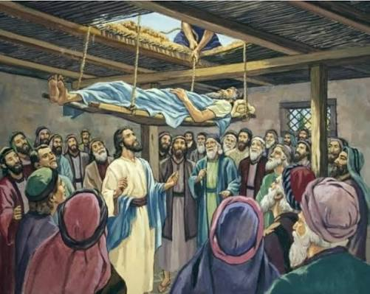

September 6, 2026

Edgefield Methodist Church
and St. Paul Campus
745 N. Pickens Bridge Road, Piney Flats, Tennessee 37686
(423) 538-5940 email:edgefieldgmc@gmail.com
Church Website: espgmc.org

Estel Williams, Pastor

“Edgefield Methodist Church is a supportive fellowship
where anyone can become a disciple of Jesus Christ”

